Brookline Community Aging Network
Re-Emerge and Re-Engage
How to Thrive in a Post-Pandemic World

Brookline Community Aging Network  Provides information to help residents remain engaged in the community.  Advocates to make Brookline an even better place to live for seniors and everyone.  Join us!  Founding Partners  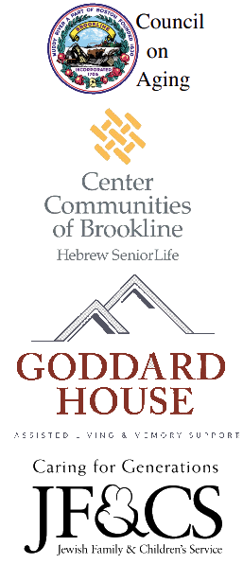 | 2023 Annual Meeting and Reception  Thursday, September 7, 2023  5:00 -7:00 pm  Brookline Senior Center 93 Winchester Street  5:00 – 6:15 Explore, Network, Enjoy music, food and drink  6:15 – 7:00 Awards and guest speakers  Guest Speakers:  Sigalle Reiss, Director, Brookline Public Health and Human Services Candace Cramer, President & CEO, Goddard House  Please join us for this free event.  BrooklineCAN Members & others are welcome.  Reservations: rsvp@brooklinecan.org  or  617-730-2770
www.BrooklineCAN.org

